Project Design Phase-II
Data Flow Diagram & User Stories

Date | 25 June 2026
Team ID | Not Given
Project Name | Rising Waters
Maximum Marks | 4 Marks

Team Members | Skill Wallet Team ID’s | Roll Numbers (College: ACET)
Mohana Deepika Kancherla (Team Leader) | SWUID2026226898 | 23MH1A0596
Flora Disowja Sarugolu | SWUID2026212008 | 24P35A0549
Santhi Illa | SWUID2026212021 | 24P35A0550
Mathan Bhavesh Hari Raghava Krishna Munaga | SWUID2026212007 | 24P35A0532

Data Flow Diagrams:

The Data Flow Diagram (DFD) illustrates how data moves through the Rising Waters flood prediction system. Weather parameters entered by users are validated and processed by the Flask application, passed to the trained machine learning model for prediction, and the resulting flood risk is displayed to users while prediction records are stored for future analysis and monitoring.

Example: (Simplified)
Example: DFD Level 0 (Industry Standard)
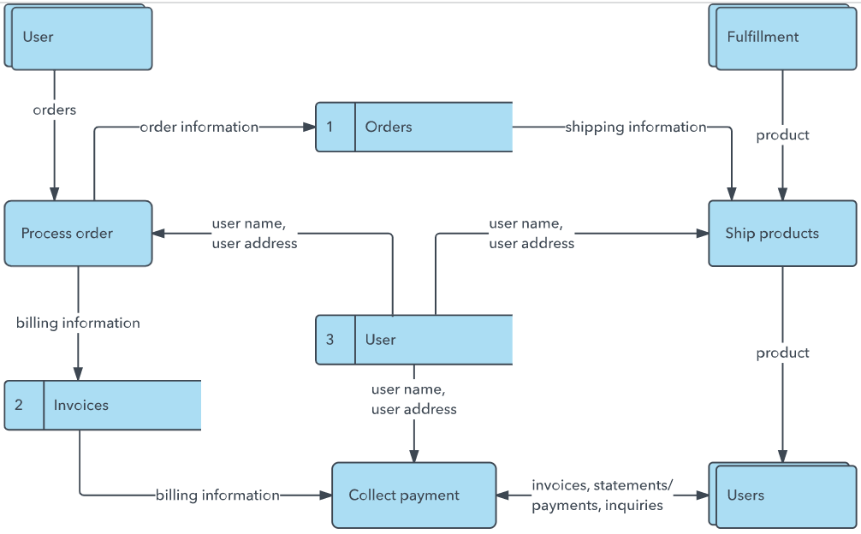
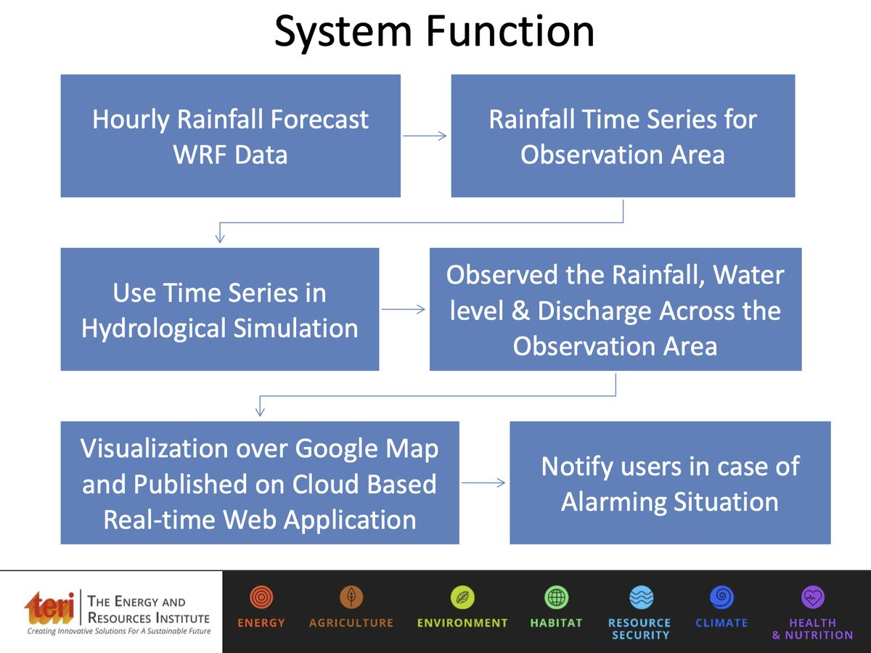
User enters weather parameters such as annual rainfall, cloud visibility, temperature, humidity, and
seasonal rainfall through the web application.The Flask application validates the input data and
prepares it for processing and prediction. Data preprocessing and feature scaling are performed
using the saved scaler object to match the model training format.The processed data is sent to
the trained XGBoost model to analyze flood risk and generate a prediction. The prediction result
(Flood / No Flood) and probability score are displayed in the user interface and stored for future analysis
and monitoring.
User Stories : Use the below template to list all the user stories for the product.
User Type | Functional Requirement (Epic) | User Story Number | User Story / Task | Acceptance criteria | Priority | Release
Disaster Management Officer | Registration | USN-1 | As a user, I can register by entering my name, email, password, and role. | User account is created successfully. | High | Sprint-1
Disaster Management Officer | Login | USN-2 | As a user, I can log in securely using my email and password. | User can access the dashboard after successful login. | High | Sprint-1
Disaster Management Officer | Dashboard | USN-3 | As a user, I can view the flood prediction dashboard. | Dashboard displays prediction options and history. | High | Sprint-1
Disaster Management Officer | Flood Prediction | USN-4 | As a user, I can enter weather parameters to predict flood risk. | System displays Flood/No Flood result with probability. | High | Sprint-1
Meteorologist | Weather Data Entry | USN-5 | As a meteorologist, I can input rainfall, temperature, humidity, cloud visibility, and seasonal rainfall data. | Input data is validated before prediction. | High | Sprint-1
Meteorologist | Prediction History | USN-6 | As a meteorologist, I can view previous flood predictions. | Previous prediction records are displayed correctly. | Medium | Sprint-2
Government Analyst | Model Performance | USN-7 | As an analyst, I can compare the accuracy of different ML models. | Accuracy and evaluation metrics are displayed. | Medium | Sprint-2
Government Analyst | Report Generation | USN-8 | As an analyst, I can generate flood prediction reports. | Reports can be viewed or downloaded successfully. | Medium | Sprint-2
Administrator | User Management | USN-9 | As an administrator, I can manage user accounts and roles. | Users can be added, updated, or removed. | High | Sprint-2
Administrator | Model Management | USN-10 | As an administrator, I can upload or update the trained ML model. | The new model is successfully loaded into the system. | High | Sprint-2
Administrator | Prediction Monitoring | USN-11 | As an administrator, I can monitor all prediction activities. | System logs and prediction records are available. | Medium | Sprint-2
Disaster Management Officer | Cloud Deployment | USN-12 | As a user, I can access the application from any location through IBM Cloud. | Application is available online with secure access. | Low | Sprint-3

